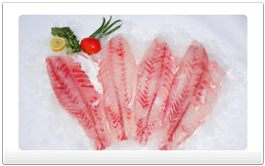

Lake Victoria perch

Nile Perch offers many advantages over other fish species which include:

* Originates from a fresh water body (Lake Victoria) under purely natural fresh lake environments
* It is a wild catch that is the inspiration for our tagline "Fresh from the wilds of Lake Victoria"
* Firm white flesh compared to other species
* No known species-related hazards including parasitic infestation
* Very low cholesterol levels for good health
* Abundance of Omega 3 & 6 polyunsaturated fatty acids
* Nile Perch is often described as "a chef's delight" as it lends itself to creative expression in terms of culinary art

## Lake Victoria Perch is usually substituted for Grouper, Snapper and Bass. Many refer to it as Strawberry Bass.

## Call Universal Seafood for more information.

## 718 842-2200